Steering Application Form – Page 1
Customer _______________________________________ Contact ______________________________________
Vehicle Model _________________________________
Type of Application _______________________________
Customer Part Number ________________________________
Current Dana Part Number _________________________________

STEERING SHAFT DIMENSIONS (See Drawing 1)
Dimension A - * Required for Application
*(End to End) Extended Length = _________________________________________
*(End to End) Maximum Operating = ______________________________________
*(End to End ) Collapsed = ____________________________________
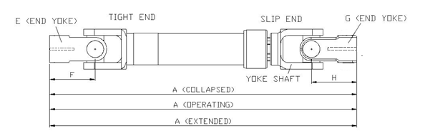
Phasing (Y) in degrees (if known) _____________ (See Drawing 4)
Z
Drawing 1
Slip End
End Yoke Part Number (G) ____________________________
End Yoke Length (H) __________________________
If part numbers are not known, attach spline data for the mating output shaft. (See drawing 2 for key dimensions)

Tight End
End Yoke Part Number (E) _______________________
End Yoke Length (F) ____________________________
If part numbers are not known, attach spline data for the mating output shaft. (See drawing 3 for key dimensions)

Signed _________________________________________ Title ________________________________________
Phone Number ______________________ Date ______________

Steering Application Form – Page 2
OUTPUT SHAFT CRITERIA

J ________________
K (Spline Major) ________________
K (Spline Minor) ________________
L (radius) ____________
Number of teeth ___________
Drawing 2 – Output shaft for end yoke “G” on drawing 1
M ________________
N (Spline Major) ______________
N (Spline Minor) ______________
P (Radius) ________________
Number of Teeth ____________
Drawing 3 – Output shaft for end yoke “E” on drawing 1

**If a splined output shaft is not being used for either the slip or the tight end, attach a sketch of the shaft that is currently being used instead of filling out the dimensions above.
Y
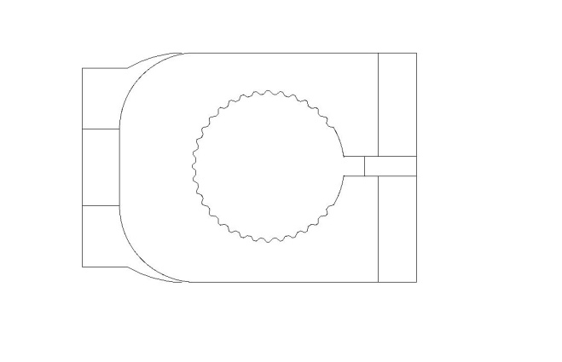
Centerline of Yoke Ears -- Yoke E
Centerline of Yoke Ears -- Yoke G (Yokeshaft)
Phasing from View Z in Drawing 1
Drawing 4 – Phasing (Refer to Drawing 1)

-If possible, attach drawing of the front and side view of the steering shaft application if a current Dana part number was not given. Also, have location dimensions in both views of the drawing.

